OCE─Macroeconomic-fiscal modeling & quarterly outlook – progress (Dec 15, 2023)
Overview and rationale
Since mid-2022, the OCE team has developed and fully implemented a quarterly macro-fiscal FPAS-type gap-model of international standard with technical support from OGResearch (with GIZ financial support).
The QMFM allows producing a Quarterly Macro-Fiscal Outlook (16 quarters ahead) and summary forecast presentation which reflect fiscal policy (deficit, revenue, government spending and demand), monetary and exchange rate policy (rules), and judgmental near-term forecasts, such as this quarter’s CPI, next quarter’s GDP. A key novel feature is that it gauges the impact of fiscal policies on output, inflation, and other macro aggregates. Nonetheless, assessing the sectoral and income distribution impacts of tax and public expenditure (and other) policies requires a multi-sectoral general equilibrium tool, also under development in OCE.
The QMFM simulates the macro effects of: alternative macro policies; of shocks (international prices, domestic food supply, energy prices,…) and policy responses; and of changes in longer-term trends (e.g., potential output, neutral interest rates and RER depreciation rate). The results provide an independent assessment and forecast of macro variables, as a basis for discussion with key interlocutors (NBR, IMF,…). Thus, the QMFM provides inputs for the integrated Macroeconomic Framework (intMF), notably for variables which are otherwise “set” (sometimes by NBR) or projected judgmentally or residually, notably real GDP, CPI, exchange rate, consumption, investment. It also provides overall consistency checks for intMF aggregates (like export and imports, deflators, domestic/external debt, and private savings).
- The key outcomes are: improved intMF projections, incl. for IMF review; independent assessment of interactions of fiscal, monetary and exchange rate policies; Quarterly Macro Fiscal Outlook report; deepened staff grasp of complex macroeconomic relations; and enhanced coordination with NBR.
Design and appropriation process
The pilot development and initial training round in Matlab took place in online sessions with OGResearch (a research consultancy based in Prague/Budapest) in April-June 2021. An all-new OCE team came on board in April 2022, consisting of 5-6 staff (incl. one Research Fellow), who learned and taught themselves to run the model and further adapted it for the Rwandan economy .
Five 1½ week workshops of hands-on training and exercises were held between Oct 2022 to Dec 2023 led by OGR, covering:
- refreshment of economic theory underlying the model (esp. DSGE, role expectations)
- adaptation of QMFM to Rwanda economy & data and MINECOFIN’s needs
- further training in Matlab, data management, and macro modeling in IRIS
- refreshment in econometrics (filters), (Bayesian) estimation, and calibration (parameter choice)
- joint development of fiscal block: deficit, revenue, government demand for G&S, other spending, of financing/debt block (financial flows, grants, and debt)
- producing forecasts and simulations with policies or exogenous shocks etc. tuned with known or expected policies, preliminary/judgmental estimates
- pilot Quarterly Economic-Fiscal Outlooks and summary forecast presentations Jan-April-June 2023
- exchange and discussion with NBR macro modeling team.

Distinctive features of the model
The main distinctive features compared to other such models as used by Central Banks are:
- elaborated fiscal block with both the deficit constituent parts (revenue, government demand for G&S, other expenditures (transfers, subsidies, net lending) and the components of each over the business cycle (structural, discretionary, and cyclical)
- breakdown of final demand into components (consumption, government demand, investment, exports, imports) allowing the model to trace the impact of shocks in these aggregates on all other variables and vice versa
- derivation of key macro variables in levels and real/nominal terms, allowing comparison with, and provision of inputs for, OCE’s other macroeconomic projections tools.

Anchored on data from integrated Macroeconomic Framework
The model draws on a monthly and quarterly OCE database that is linked to the intMF and its source data (NBR, NISR National Accounts and CPI components, debt date from DebtDG, latest WEO). It uses all available up-to-date information and near-term forecasts, judgments on output, inflation, interest and exchange rates (for current and next few quarters), as well as the results of OCE’s now/forecasting tool for current and next-quarter real GDP.

Complementary to and providing inputs into intMF projections and IMF review discussions
The intMF is an accounting framework not a model. Real GDP is supply-driven (sum of sector projections), mostly exogenous. The CPI, other deflators, and exchange rate are targets, set exogenously. There is no impact of demand on output, exports and imports are projected in the BOP, private investment is ‘set’ judgmentally while private consumption is residual.
The QMFM, in contrast, is a full macro, business-cycle model. Real GDP is demand-driven (the sum of final demands, each forecast with its own behavioral equation) with output levels determined vis-a-vis potential or trend output. The model captures both direct effect of government consumption and investment on output and indirect effect of fiscal policy on private demand (fiscal impulse) and hence output, including the multiplier effects of both. Prices, exchange rate and interest rates are endogenous, simultaneously determined with outputs and final demands. It has forward-looking expectations which are key for private sector behavior and the monetary and exchange rate policy rules of the NBR.

- The QMFM forecasts feed into the intMF, in consultation with NBR which has a similar model (without a detailed fiscal block). At the same time, the intMF’s fiscal projections or program targets—and semester and quarterly breakdown of deficit, revenue and government demand—feed into the QMFM to trace the impact of the fiscal variables on output and inflation and other variables. This leads to iterative fine tuning of the intMF/program projections for real and nominal GDP, CPI, exchange rate path, and final demands.
Illustrative forecast output
The charts and tables in the Annex provide illustrative forecast results, which are embodied in the QMFO.
Next steps and agenda
Following the final Dec 4-8 workshop, the team is completing the Nov 2023 forecast round, with outputs:
- final draft Quarterly Economic-Fiscal Outlook (report)—January
- draft Summary Forecast Presentation (ppt) and review process—December
- forecast presentation—January
- assignment responsibilities and division of labor within team, based on new structure MPDG
- at least quarterly update/improvement of QMFM and intMF, discussed with NBR and others
(next one in January, in advance of March IMF review—macro projection/modeling committee)

Annex 1. Illustrative forecast output
…..quarterly inflation and output forecast, and underlying policy indicators…….
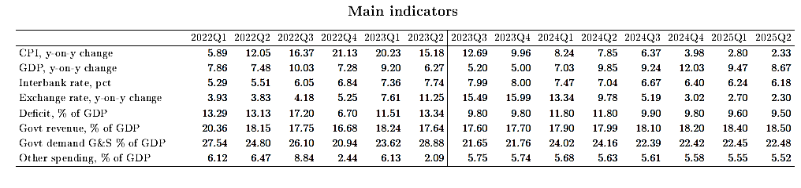
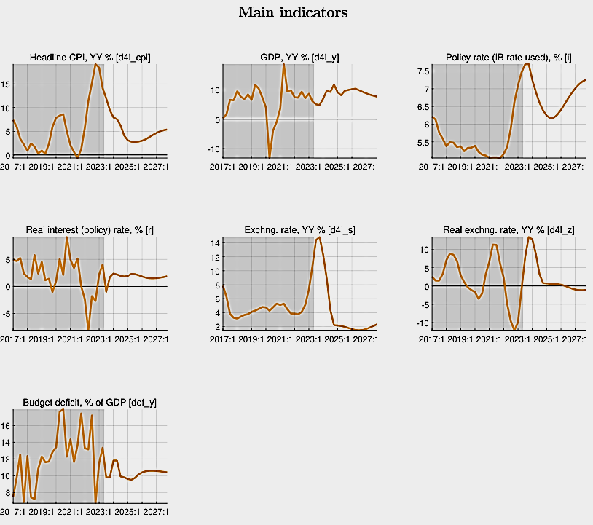

…..tracing and projecting budget deficits and its constituent parts and (structural, …) components….

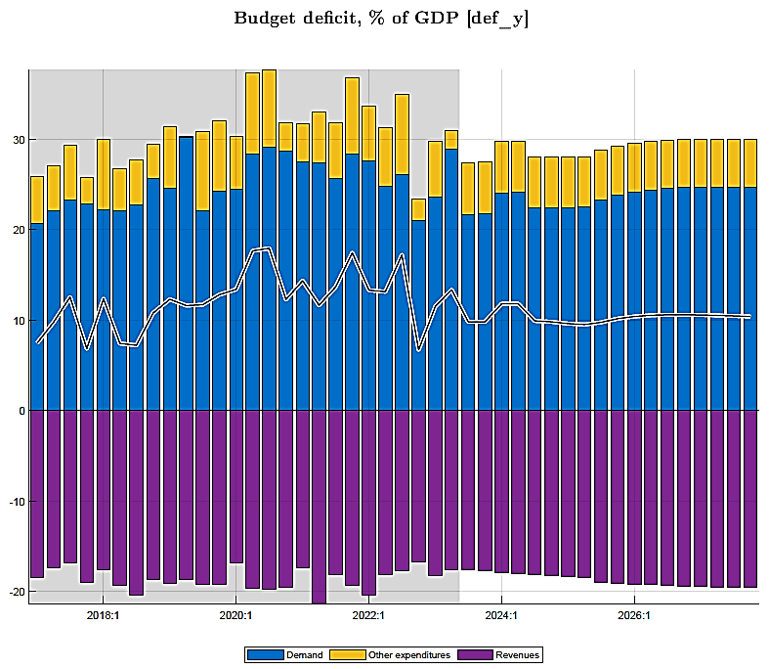

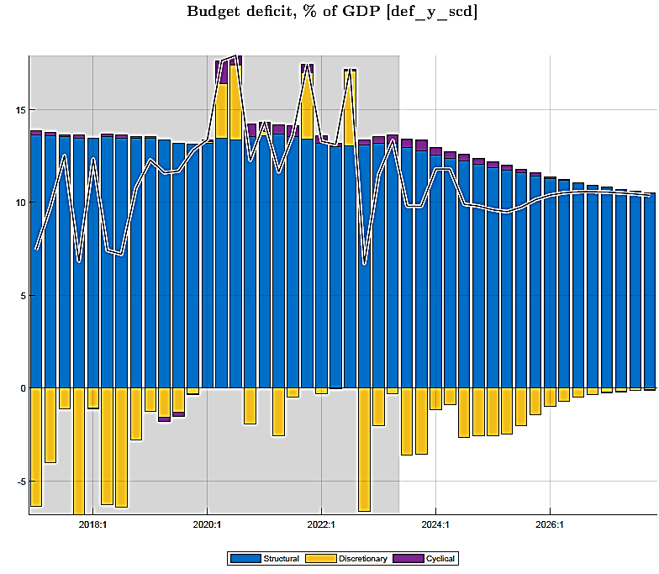
…projection final demands in real terms: investment, gov demand, exports, imports, consumption…

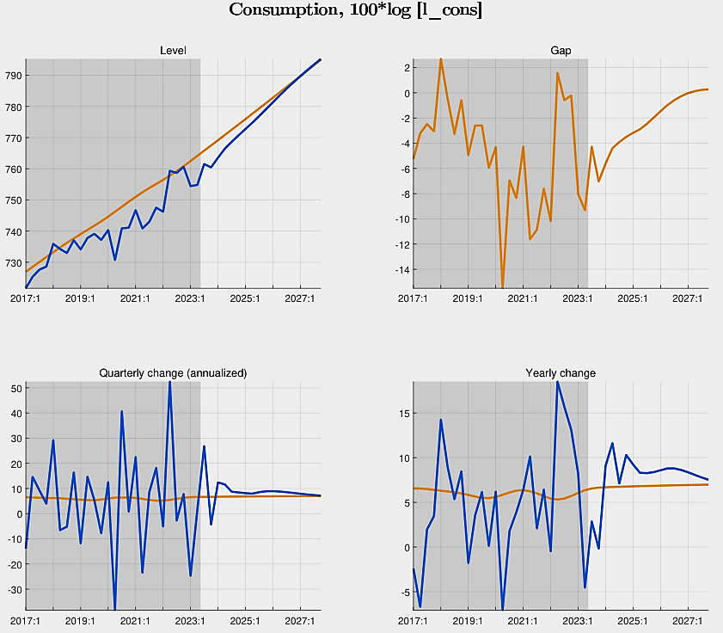

….. each final demand component—in deviation of its trend—has its drivers….
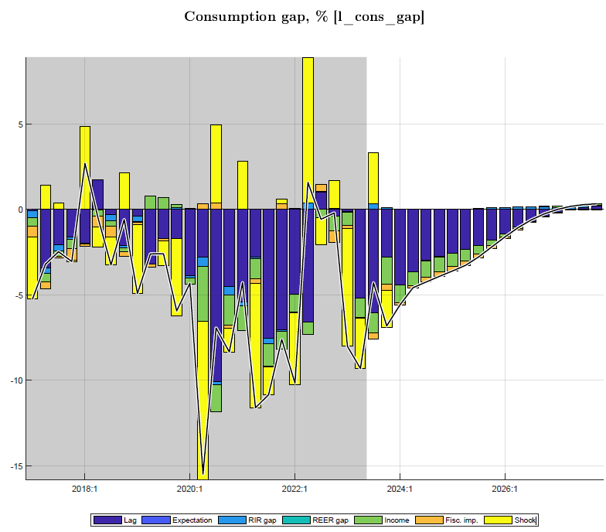
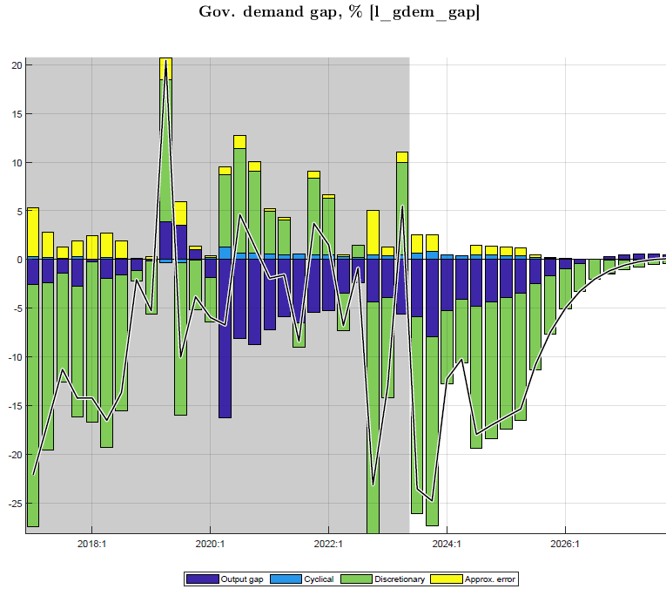
…annualized forecast of macro aggregates for comparison with projections of intMF….
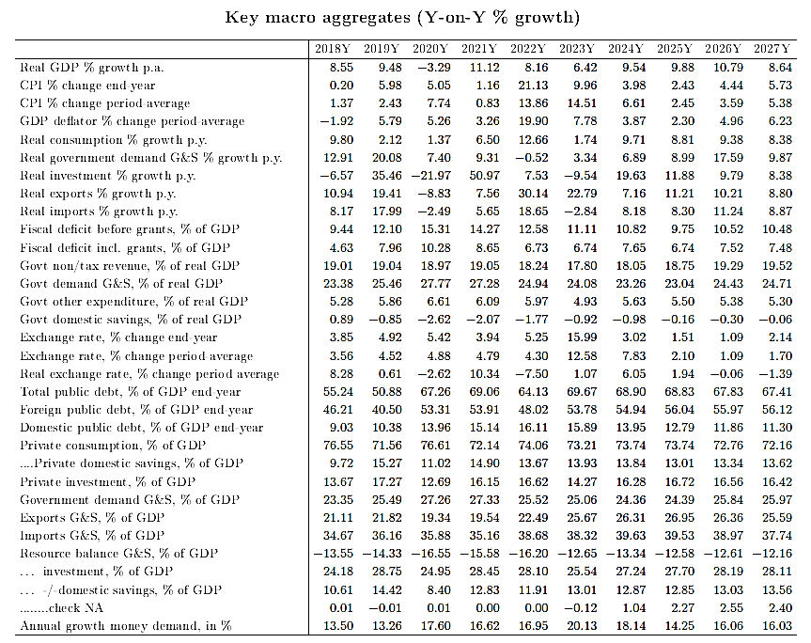

Figure 1. Main relationships and transmission mechanisms in Quarterly Macro-Fiscal Model
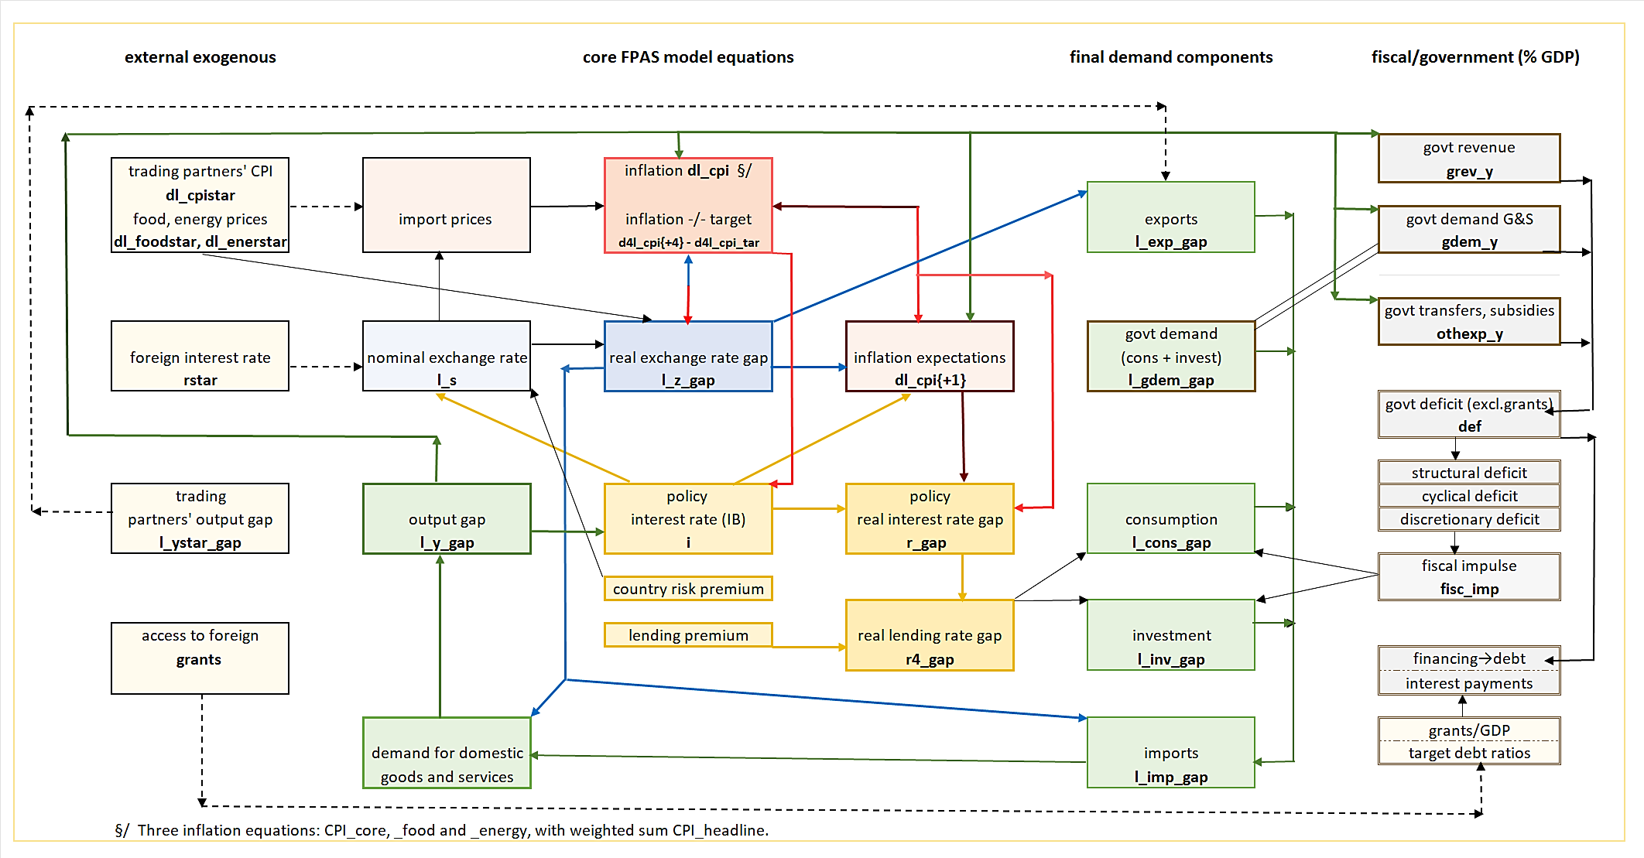

Forecasting Policy Analysis System (FPAS) is a macro modeling approach used by central banks for Inflation Targeting (IT) as well as ministries of finance. The NBR developed and implemented its FPAS during 2011-21 (cf. NBR, Economic Review, 2014, 2015, 2018 and IMF/WP, 2014, 2020).

